After calculating the maximum flow, the max-flow algorithm creates a min-cut in the graph, according to the max flow-min cut theorem. Given a network with capacities of the edges, print the edges of the min-cut.

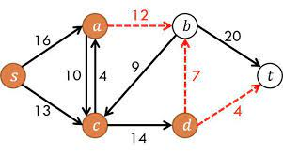

For example, the red marked edges constitute the min-cut of the above graph.